WADS LAB 23 Jan 2025

TASK

Sai Ganesh Eswaraprasad

HU22CSEN0100287

1. Display xml file using css file

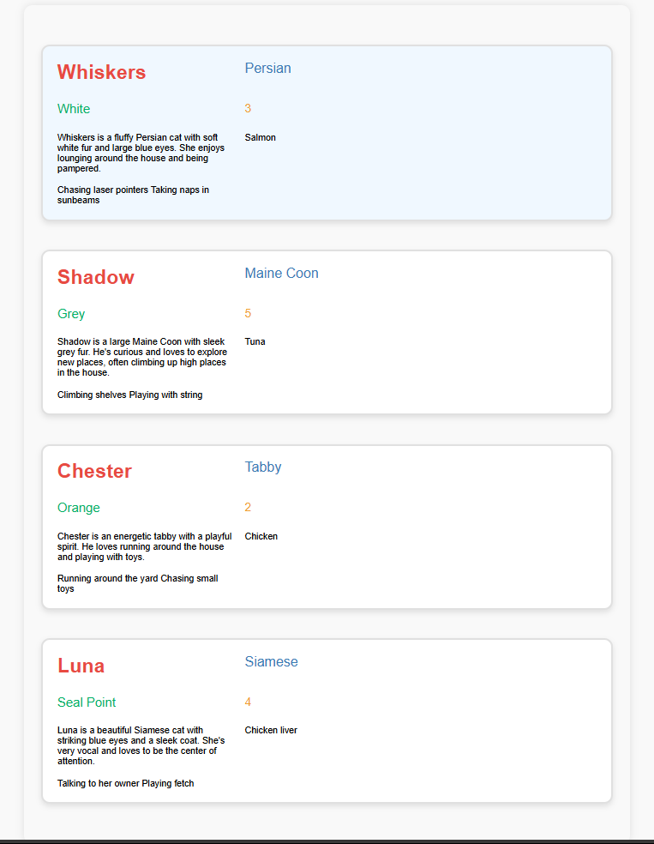

CODE:

(cats.css)

cats {

    font-family: 'Arial', sans-serif;

    background-color: #f9f9f9;

    margin: 40px;

    padding: 30px;

    border-radius: 15px;

    box-shadow: 0 0 15px rgba(0, 0, 0, 0.1);

    max-width: 1000px;

    margin-left: auto;

    margin-right: auto;

  }

  cat {

    background-color: #ffffff;

    margin: 40px 0;

    padding: 25px;

    border: 3px solid #e0e0e0;

    border-radius: 15px;

    box-shadow: 0 4px 10px rgba(0, 0, 0, 0.1);

    display: grid;

    grid-template-columns: 1fr 2fr;

    gap: 20px;

  }

  cat:hover {

    background-color: #f0f8ff;

  }

  .cat-info {

    padding: 10px;

    display: flex;

    flex-direction: column;

    justify-content: space-between;

  }

  name {

    font-size: 2.2em;

    font-weight: bold;

    color: #e74c3c;

    margin-bottom: 10px;

  }

  breed {

    font-size: 1.5em;

    color: #2980b9;

    margin-bottom: 8px;

  }

  color {

    font-size: 1.4em;

    color: #27ae60;

    margin-bottom: 8px;

  }

  age {

    font-size: 1.3em;

    color: #f39c12;

    margin-bottom: 8px;

  }

   .cat-description {

    padding: 10px;

    background-color: #fafafa;

    border-radius: 10px;

  }

  .description {

    font-size: 1.2em;

    color: #34495e;

    margin-bottom: 20px;

  }

  .favoriteFood {

    font-size: 1.3em;

    font-weight: bold;

    color: #8e44ad;

    margin-bottom: 10px;

  }

  .likes {

    margin-top: 20px;

  }

  .likes item {

    font-size: 1.2em;

    color: #666;

    padding-left: 20px;

    margin-bottom: 5px;

    display: list-item;

  }

  .likes item:last-child {

    margin-bottom: 0;

  }

  cat + cat {

    margin-top: 50px;

  }

(cats.xml)

<?xml version="1.0" encoding="UTF-8"?>

<?xml-stylesheet type="text/css" href="cats.css"?>

<cats>

  <cat>

    <name>Whiskers</name>

    <breed>Persian</breed>

    <color>White</color>

    <age>3</age>

    <description>Whiskers is a fluffy Persian cat with soft white fur and large blue eyes. She enjoys lounging around the house and being pampered.</description>

    <favoriteFood>Salmon</favoriteFood>

    <likes>

      <item>Chasing laser pointers</item>

      <item>Taking naps in sunbeams</item>

    </likes>

  </cat>

  <cat>

    <name>Shadow</name>

    <breed>Maine Coon</breed>

    <color>Grey</color>

    <age>5</age>

    <description>Shadow is a large Maine Coon with sleek grey fur. He's curious and loves to explore new places, often climbing up high places in the house.</description>

    <favoriteFood>Tuna</favoriteFood>

    <likes>

      <item>Climbing shelves</item>

      <item>Playing with string</item>

    </likes>

  </cat>

  <cat>

    <name>Chester</name>

    <breed>Tabby</breed>

    <color>Orange</color>

    <age>2</age>

    <description>Chester is an energetic tabby with a playful spirit. He loves running around the house and playing with toys.</description>

    <favoriteFood>Chicken</favoriteFood>

    <likes>

      <item>Running around the yard</item>

      <item>Chasing small toys</item>

    </likes>

  </cat>

  <cat>

    <name>Luna</name>

    <breed>Siamese</breed>

    <color>Seal Point</color>

    <age>4</age>

    <description>Luna is a beautiful Siamese cat with striking blue eyes and a sleek coat. She's very vocal and loves to be the center of attention.</description>

    <favoriteFood>Chicken liver</favoriteFood>

    <likes>

      <item>Talking to her owner</item>

      <item>Playing fetch</item>

    </likes>

  </cat>

</cats>

1. 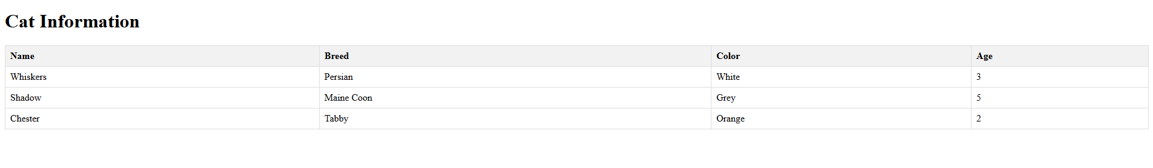Construct xml data in tabular form using Javascript

CODE:

<!DOCTYPE html>

<html lang="en">

<head>

    <meta charset="UTF-8">

    <meta name="viewport" content="width=device-width, initial-scale=1.0">

    <title>Cat Information</title>

    <style>

        table { width: 100%; border-collapse: collapse; }

        th, td { padding: 8px; border: 1px solid #ddd; text-align: left; }

        th { background-color: #f2f2f2; }

    </style>

</head>

<body>

<h1>Cat Information</h1>

<table id="catTable">

    <thead>

        <tr>

            <th>Name</th>

            <th>Breed</th>

            <th>Color</th>

            <th>Age</th>

        </tr>

    </thead>

    <tbody>

        <!-- JavaScript will populate the table -->

    </tbody>

</table>

<script>

// Function to load XML data and display it in the table

function loadXMLData() {

    const xmlString = `<?xml version="1.0" encoding="UTF-8"?>

    <cats>

        <cat>

            <name>Whiskers</name>

            <breed>Persian</breed>

            <color>White</color>

            <age>3</age>

        </cat>

        <cat>

            <name>Shadow</name>

            <breed>Maine Coon</breed>

            <color>Grey</color>

            <age>5</age>

        </cat>

        <cat>

            <name>Chester</name>

            <breed>Tabby</breed>

            <color>Orange</color>

            <age>2</age>

        </cat>

    </cats>`;

    // Parse the XML string into an XML document

    const parser = new DOMParser();

    const xmlDoc = parser.parseFromString(xmlString, "application/xml");

    // Get all cat nodes

    const cats = xmlDoc.getElementsByTagName("cat");

    // Loop through each cat and add rows to the table

    const tableBody = document.getElementById("catTable").getElementsByTagName("tbody")[0];

    for (let i = 0; i < cats.length; i++) {

        const cat = cats[i];

        const name = cat.getElementsByTagName("name")[0].textContent;

        const breed = cat.getElementsByTagName("breed")[0].textContent;

        const color = cat.getElementsByTagName("color")[0].textContent;

        const age = cat.getElementsByTagName("age")[0].textContent;

        // Create a new table row

        const row = document.createElement("tr");

        row.innerHTML = `<td>${name}</td><td>${breed}</td><td>${color}</td><td>${age}</td>`;

        tableBody.appendChild(row);

    }

}

// Load the data when the page is ready

window.onload = loadXMLData;

</script>

</body>

</html>

1. 2025 Calendar Using xml,js,css,html

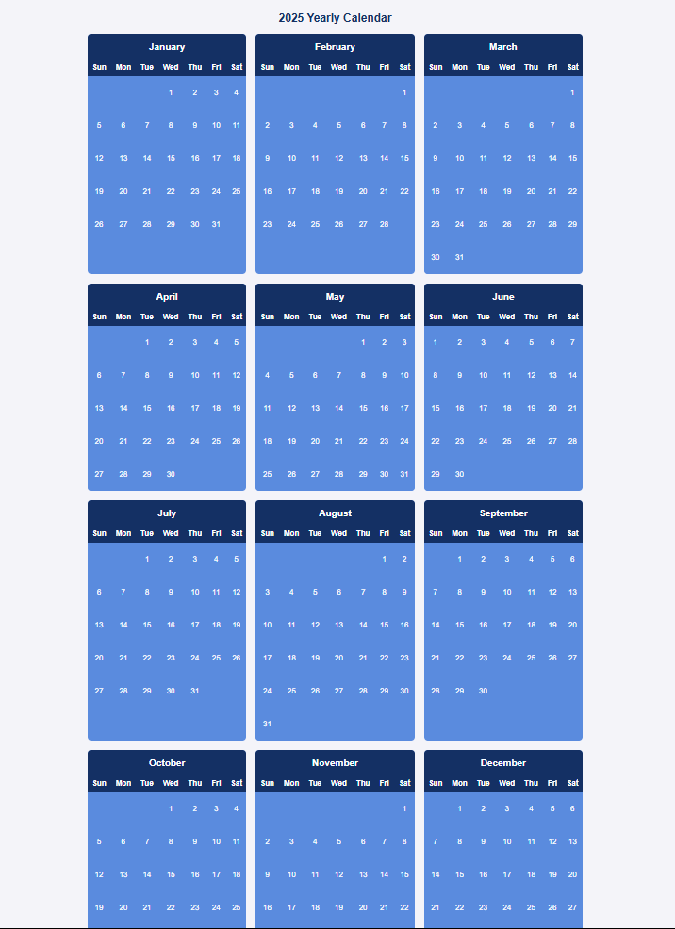

CODE:

<!DOCTYPE html>

<html lang="en">

<head>

    <meta charset="UTF-8">

    <meta name="viewport" content="width=device-width, initial-scale=1.0">

    <title>2025 Calendar</title>

    <style>

        body {

            font-family: Arial, sans-serif;

            background-color: #f4f4f9;

            margin: 0;

            padding: 20px;

            display: flex;

            flex-direction: column;

            align-items: center;

            justify-content: center;

        }

        h1 {

            color: #003366;

            margin-bottom: 20px;

            font-size: 24px;

        }

        #calendarContainer {

            display: grid;

            grid-template-columns: repeat(3, 1fr);

            gap: 20px;

            width: 150%;

            max-width: 1050px;

        }

        .month-container {

            background-color: #4A90E2;

            color: white;

            border-radius: 8px;

            overflow: hidden;

            display: flex;

            flex-direction: column;

            align-items: center;

        }

        .month-name {

            text-align: center;

            font-weight: bold;

            font-size: 20px;

            padding: 15px;

            background-color: #003366;

            width: 100%;

        }

        table {

            width: 10%;

            border-collapse: collapse;

        }

        th, td {

            text-align: center;

            padding: 10px;

            color: white;

            font-size: 16px;

            width: 1200px; /\* Further increased width \*/

        }

        th {

            background-color: #003366;

        }

        td {

            background-color: #4A90E2;

            height: 50px; /\* Kept height balanced \*/

        }

        td.empty {

            background-color: #4A90E2;

            color: #4A90E2;

        }

    </style>

</head>

<body>

<h1>2025 Yearly Calendar</h1>

<div id="calendarContainer"></div>

<script>

// XML data for the 2025 calendar

const xmlData = `<?xml version="1.0" encoding="UTF-8"?>

<calendar>

  <year value="2025">

    <month name="January" days="31" />

    <month name="February" days="28" />

    <month name="March" days="31" />

    <month name="April" days="30" />

    <month name="May" days="31" />

    <month name="June" days="30" />

    <month name="July" days="31" />

    <month name="August" days="31" />

    <month name="September" days="30" />

    <month name="October" days="31" />

    <month name="November" days="30" />

    <month name="December" days="31" />

  </year>

</calendar>`;

function loadCalendar() {

    const parser = new DOMParser();

    const xmlDoc = parser.parseFromString(xmlData, "application/xml");

    const months = xmlDoc.getElementsByTagName("month");

    const calendarContainer = document.getElementById("calendarContainer");

    for (let month of months) {

        const monthName = month.getAttribute("name");

        const daysInMonth = parseInt(month.getAttribute("days"));

        // Create container for each month

        const monthContainer = document.createElement("div");

        monthContainer.className = "month-container";

        // Month name header

        const monthHeader = document.createElement("div");

        monthHeader.className = "month-name";

        monthHeader.textContent = monthName;

        monthContainer.appendChild(monthHeader);

        // Create table for each month

        const table = document.createElement("table");

        // Add weekday headers

        const thead = document.createElement("thead");

        const headerRow = document.createElement("tr");

        ["Sun", "Mon", "Tue", "Wed", "Thu", "Fri", "Sat"].forEach(day => {

            const th = document.createElement("th");

            th.textContent = day;

            headerRow.appendChild(th);

        });

        thead.appendChild(headerRow);

        table.appendChild(thead);

        // Add days

        const tbody = document.createElement("tbody");

        let dayCounter = 1;

        let firstDay = new Date(`2025-${monthName}-01`).getDay();

        let row = document.createElement("tr");

        // Add empty cells for days before the first of the month

        for (let i = 0; i < firstDay; i++) {

            const cell = document.createElement("td");

            cell.className = "empty";

            row.appendChild(cell);

        }

        // Add days of the month

        for (let i = firstDay; i < 7; i++) {

            if (dayCounter <= daysInMonth) {

                const cell = document.createElement("td");

                cell.textContent = dayCounter++;

                row.appendChild(cell);

            }

        }

        tbody.appendChild(row);

        // Continue adding rows until the month is complete

        while (dayCounter <= daysInMonth) {

            row = document.createElement("tr");

            for (let i = 0; i < 7 && dayCounter <= daysInMonth; i++) {

                const cell = document.createElement("td");

                cell.textContent = dayCounter++;

                row.appendChild(cell);

            }

            tbody.appendChild(row);

        }

        table.appendChild(tbody);

        monthContainer.appendChild(table);

        calendarContainer.appendChild(monthContainer);

    }

}

// Load the calendar when the page loads

window.onload = loadCalendar;

</script>

</body>

</html>